**SDG7 – AFFORDABLE AND CLEAN ENERGY**

One of our biggest global problems is the demand for affordable and clean energy in many countries. Our goal is to demonstrate the value of energy in the context of a story, using data visualization. We want to illustrate what repercussions we're going to face if we don't take action and what we can do to tackle the crisis.

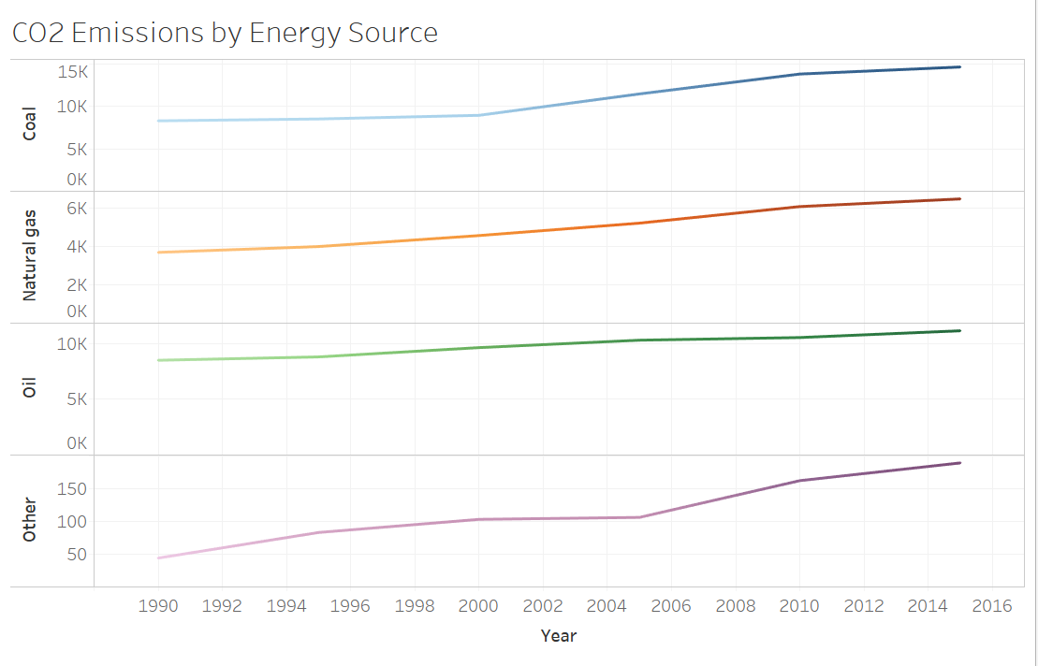

The graph below shows the CO2 Emissions by 3 main energy sources: Coal, Natural Gas, Oil and also some others Energy Source by the following year. There were some problems when executing the forecasting process, however, as we can see from the graph, the CO2 Emissions will increase significantly though the years if we are not doing anything.

**If we do nothing:**

* One in 7 people still lacks electricity, and most of them live in rural areas of the developing world.
* The bad energy sources will continue to affect climate change, which now produces around 60% of greenhouse gases.

**If we do something:**

* More efficient energy standards could reduce building and industry electricity consumption by 14 percent.
* More power will be generating through renewable sources.

**Solutions people can take at home:**

* Change the habit, especially the way we use energy. For example, stop rely on polluting and unhealthy fuels for cooking.